Boundary-Based Composition

Definition
# Source: AI Source: Provided by: [Data Path: Persons Table -> ID Column: 1, Name_En Column: Motasem Essam] -> From: [ChatGPT] on [7/25/2026]
Boundary-Based Composition is a type of geometric figure composition in which two or more geometric figures are combined or arranged according to how their boundaries relate to one another.
The boundaries may meet at a point, share a line segment, follow a common curved edge, touch tangentially, or form the outer boundary of a larger composite figure.
Simple definition: Boundary-based composition combines geometric figures by using the relationships between their edges, sides, curves, or other boundaries.
Examples include:
- Two squares sharing a side.
- A rectangle joined to a semicircle along a diameter.
- Two circles touching at one point.
- Several polygons whose outer edges form one larger polygon.

Main Classification
# Source: AI Source: Provided by: [Data Path: Persons Table -> ID Column: 1, Name_En Column: Motasem Essam] -> From: [ChatGPT] on [7/25/2026]
The following is a practical, descriptive classification, not a universally standardized mathematical taxonomy. The categories can overlap.

1. Full-Boundary Sharing Composition
# Source: AI Source: Provided by: [Data Path: Persons Table -> ID Column: 1, Name_En Column: Motasem Essam] -> From: [ChatGPT] on [7/25/2026]
Two figures share an entire side or boundary segment.
Example: Two equal squares joined along one complete side.
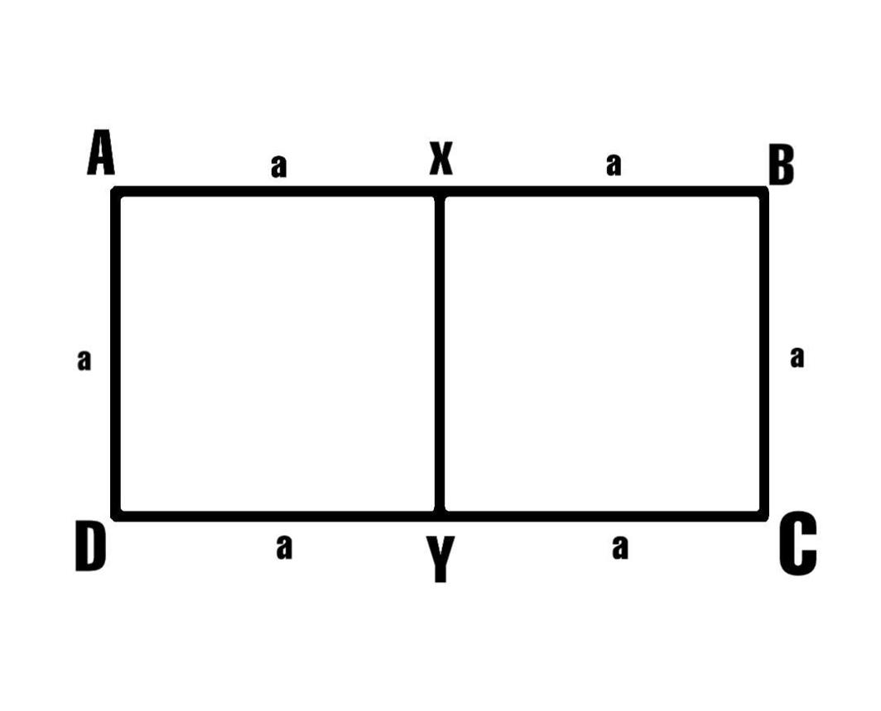
Detailed Explanation and Examples
Definition: Two geometric figures share an entire side or boundary segment, allowing them to form a combined configuration.
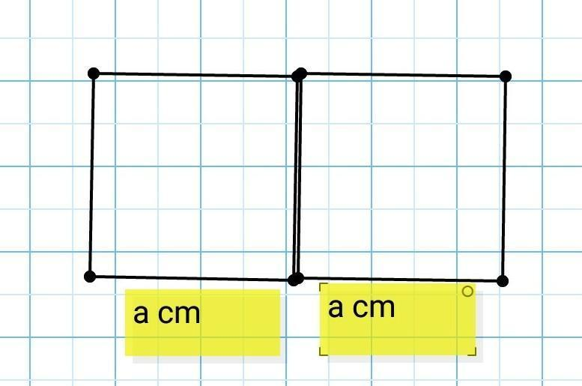
Example: Two squares, each with side length $4$units, share one complete side.
The combined figure is a rectangle with length $8$and width $4$.
Total area:
$$A_{\text{total}}=4^{2}+4^{2}=32$$
The shared side is internal, so it is not included in the outer perimeter.
$$P_{\text{total}}=2\left(8+4\right)$$
$$\boxed{A_{\text{total}}=32, P_{\text{total}}=24}$$

2. Partial-Boundary Sharing Composition
# Source: AI Source: Provided by: [Data Path: Persons Table -> ID Column: 1, Name_En Column: Motasem Essam] -> From: [ChatGPT] on [7/25/2026]
Figures share only a portion of their boundaries.
Example: A small rectangle attached to part of a larger rectangle's side.
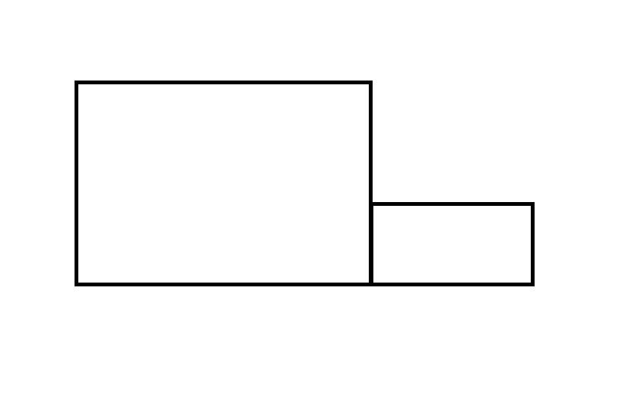
Detailed Explanation and Examples
Definition: Two figures share only a portion of their boundaries rather than an entire side.
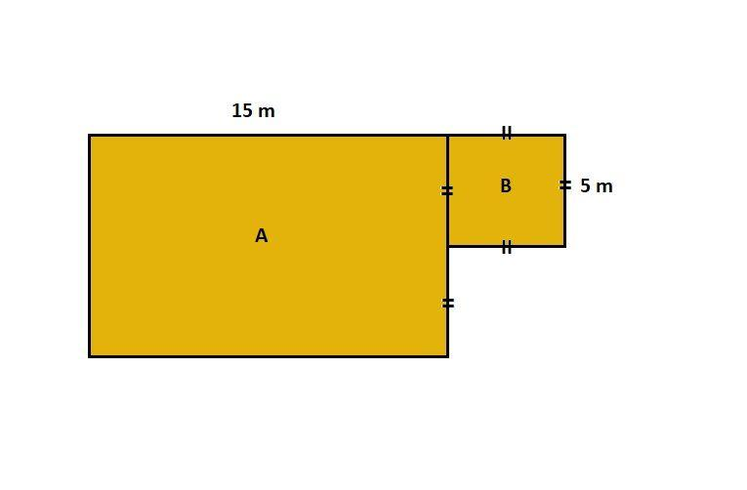
Example: Two rectangles have areas $24$and $12$square units and share a boundary segment of length $2$units. Assume their interiors do not overlap and this is their only shared boundary.
The total area is:
$$A_{\text{total}}=24+12$$
$$\boxed{A_{\text{total}}=36}$$
If their individual perimeters are $P_{1}$and $P_{2}$, the combined outer perimeter is:
$$\boxed{P_{\text{total}}=P_{1}+P_{2}-2s}$$
where $s=2$is the shared boundary length.
The shared segment is subtracted twice because it was counted in both individual perimeters but is internal to the combined figure.

3. Point-Contact Composition
# Source: AI Source: Provided by: [Data Path: Persons Table -> ID Column: 1, Name_En Column: Motasem Essam] -> From: [ChatGPT] on [7/25/2026]
Figures meet at a single boundary point.
Example: Two externally tangent circles.
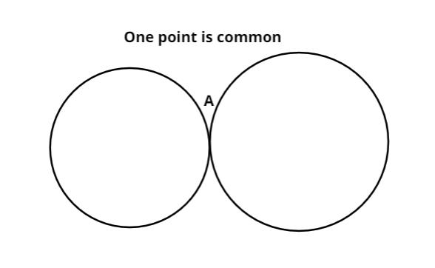
Detailed Explanation and Examples
Definition: Two or more figures meet at exactly one boundary point without sharing a boundary segment.
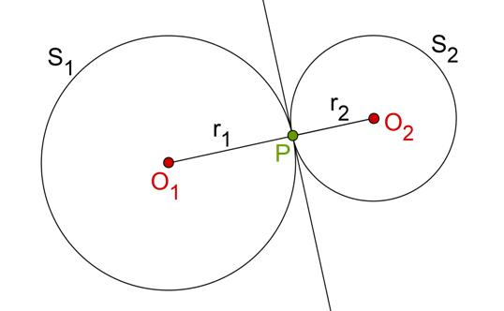
Example: Two circles have radii $r_{1}=3$and $r_{2}=2$units. Their centers are $5$units apart.
For external tangency:
$$d=r_{1}+r_{2}$$
$$5=3+2$$
The circles touch at exactly one point.
Their total area, counting both circular regions, is:
$$A_{\text{total}}=π{\left(3\right)}^{2}+π{\left(2\right)}^{2}$$
$$\boxed{A_{\text{total}}=13π}$$
Because the circles meet only at one point, their intersection has zero area.

4. Straight–Curved Boundary Composition
# Source: AI Source: Provided by: [Data Path: Persons Table -> ID Column: 1, Name_En Column: Motasem Essam] -> From: [ChatGPT] on [7/25/2026]
A straight boundary of one figure meets or joins a curved boundary of another.
Example: A rectangle joined to a semicircle along the semicircle's diameter.
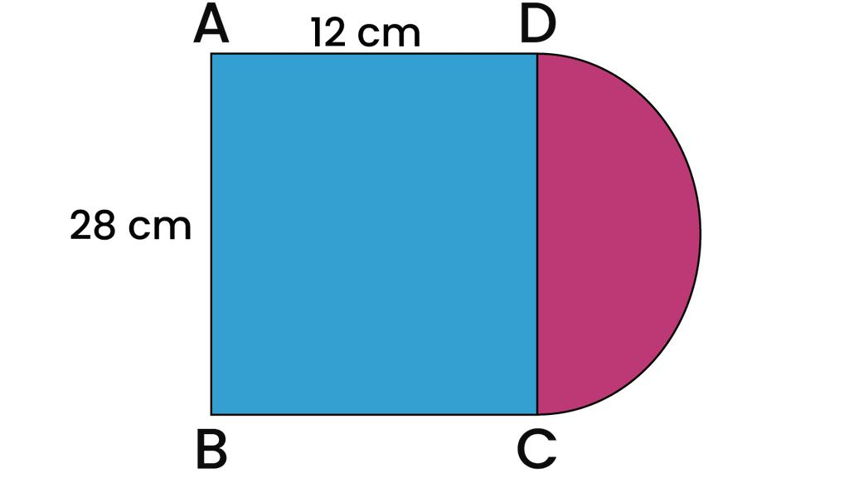
Detailed Explanation and Examples
Definition: A composition in which a straight boundary and a curved boundary meet or are joined to create a larger figure.
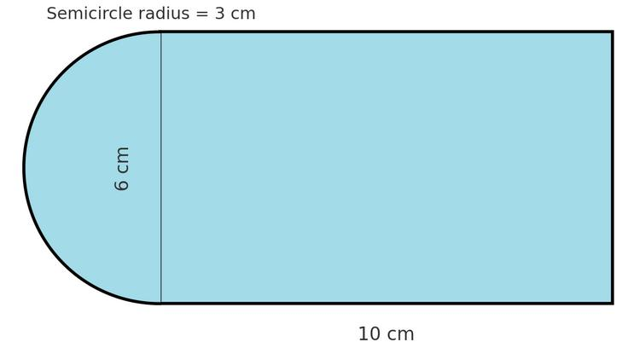
Example: A rectangle measuring $8×6$units is joined to a semicircle of radius $3$units along a side of length $6$.
The combined area is:
$$A_{\text{total}}=8\left(6\right)+\frac{1}{2}π{\left(3\right)}^{2}$$
$$\boxed{A_{\text{total}}=48+\frac{9π}{2}}$$
The outer perimeter consists of the rectangle's two long sides, the opposite short side, and the semicircular arc. The shared diameter is internal.
$$P=8+8+6+π\left(3\right)$$
$$\boxed{P=22+3π}$$

5. Tangential Boundary Composition
# Source: AI Source: Provided by: [Data Path: Persons Table -> ID Column: 1, Name_En Column: Motasem Essam] -> From: [ChatGPT] on [7/25/2026]
Figures touch smoothly at a boundary point, typically with a common tangent.
Example: Two circles touching externally at one point.
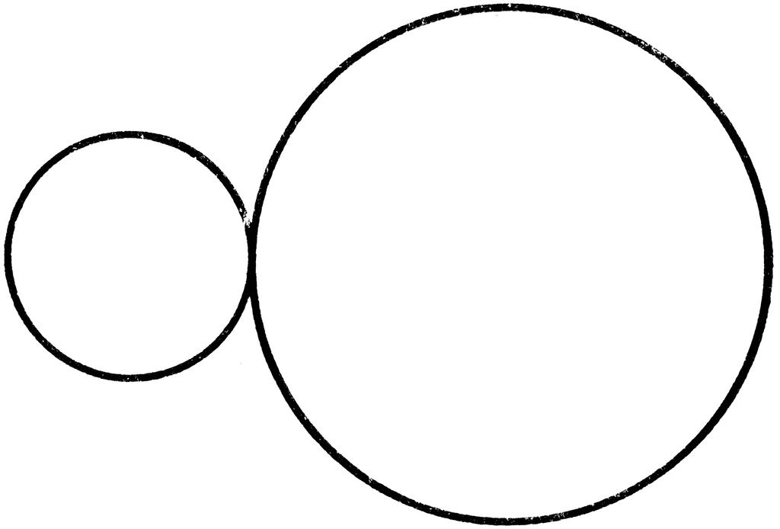
Detailed Explanation and Examples
Definition: Figures have boundaries that touch at a point without crossing there. In the usual smooth-curve setting, their tangent lines at the contact point coincide.
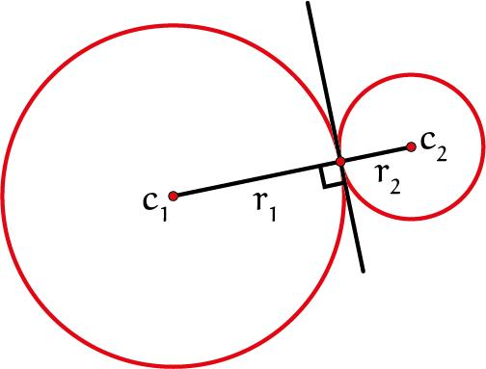
Example: Two circles with radii $4$and $3$units touch externally.
Their center distance is:
$$d=r_{1}+r_{2}=4+3=7$$
The radii drawn to the contact point lie along the line connecting the centers. A common tangent at the contact point is perpendicular to that line.
Important distinction: Tangency is a special type of point contact. Not every point contact is tangential; two curves may meet at a point and cross there.

6. Composite-Outer-Boundary Composition
# Source: AI Source: Provided by: [Data Path: Persons Table -> ID Column: 1, Name_En Column: Motasem Essam] -> From: [ChatGPT] on [7/25/2026]
Multiple figures combine so that their exposed edges form the boundary of a larger figure.
Example: Several rectangles joined to form an L-shaped region.
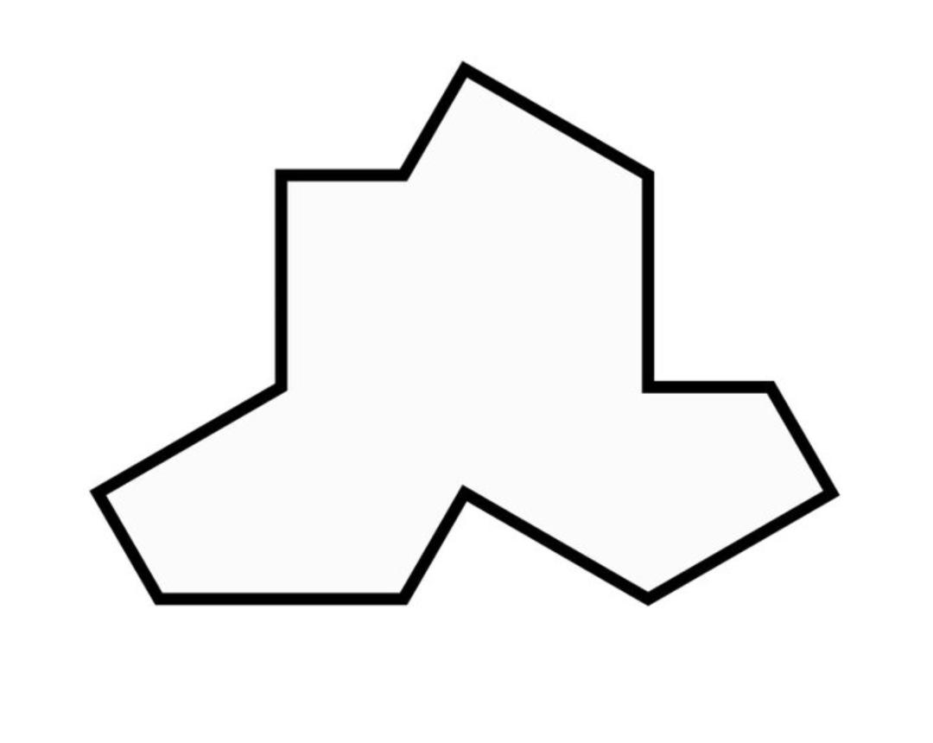
Detailed Explanation and Examples
Definition: Multiple figures are joined so that their exposed boundaries form the outer boundary of one larger composite figure.
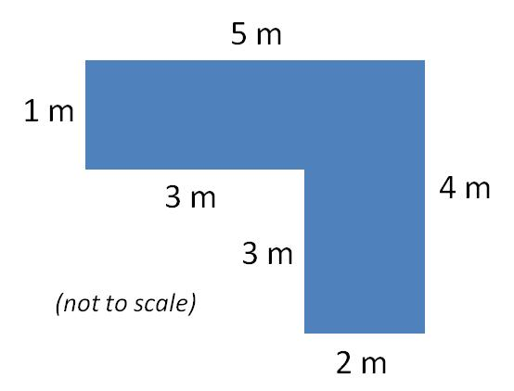
Example: Three rectangles are joined edge-to-edge to form an L-shaped region.
If the rectangles have no overlapping interiors, their total area is:
$$\boxed{A_{\text{total}}=A_{1}+A_{2}+A_{3}}$$
To calculate the perimeter, add the exposed outer edges only. Any shared internal edge must be excluded.
This approach is useful for calculating the area and perimeter of irregular composite figures.

7. Intersecting-Boundary Composition
# Source: AI Source: Provided by: [Data Path: Persons Table -> ID Column: 1, Name_En Column: Motasem Essam] -> From: [ChatGPT] on [7/25/2026]
Boundaries cross or intersect, dividing the combined configuration into distinct regions.
Example: Two intersecting circles.
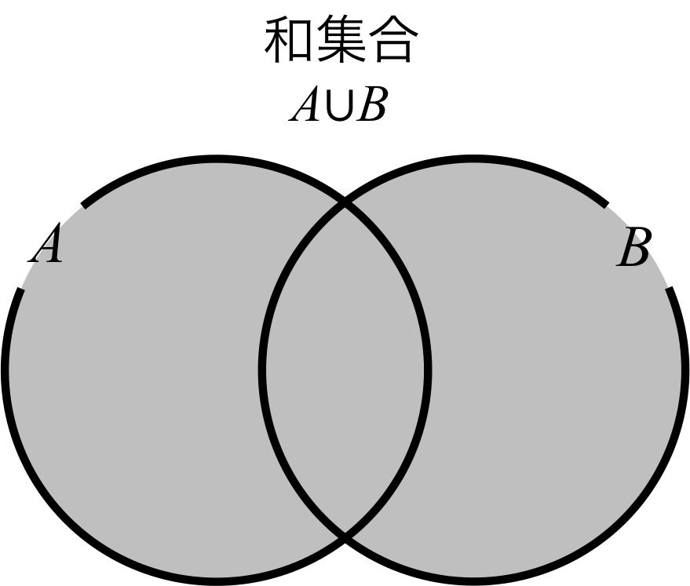
Detailed Explanation and Examples
Definition: Two or more figures have boundaries that cross or intersect, producing multiple regions in the combined configuration.
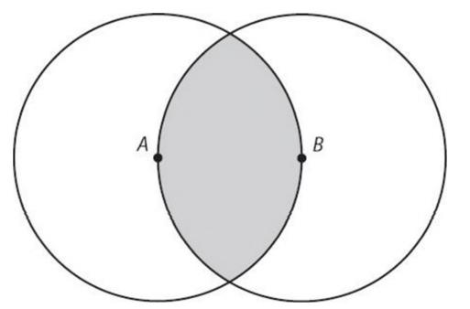
Example: Two circles overlap and form a lens-shaped intersection.
Suppose circle $A$has area $A_{A}$, circle $B$has area $A_{B}$, and their shared lens has area $A_{I}$.
The area covered by either circle is:
$$\boxed{A\left(A∪B\right)=A_{A}+A_{B}-A_{I}}$$
The intersection area is subtracted once because it was counted in both circle areas.
If the circles have equal radius $r$and center distance $d$, where $0<d<2r$, their intersection area is:
$$A_{I}=2r^{2}\cos^{-1}\left(\frac{d}{2r}\right)-\frac{d}{2}\sqrt{4r^{2}-d^{2}}$$
This formula applies to two intersecting circles of equal radius.

Important Formulas
# Source: AI Source: Provided by: [Data Path: Persons Table -> ID Column: 1, Name_En Column: Motasem Essam] -> From: [ChatGPT] on [7/25/2026]
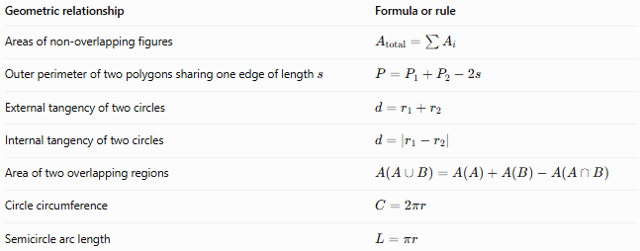
Geometric relationship | Formula or rule
Areas of non-overlapping figures | $$A_{\text{total}}=\sum{A_{i}}$$
Outer perimeter of two polygons sharing one edge of length $s$ | $$P=P_{1}+P_{2}-2s$$
External tangency of two circles | $$d=r_{1}+r_{2}$$
Internal tangency of two circles | $$d=∣r_{1}-r_{2}∣$$
Area of two overlapping regions | $$A\left(A∪B\right)=A\left(A\right)+A\left(B\right)-A\left(A∩B\right)$$
Circle circumference | $$C=2πr$$
Semicircle arc length | $$L=πr$$
Here, $d$denotes the distance between the circle centers, and $r_{1},r_{2}$are their radii.

Boundary-Based Composition vs. Related Concepts
# Source: AI Source: Provided by: [Data Path: Persons Table -> ID Column: 1, Name_En Column: Motasem Essam] -> From: [ChatGPT] on [7/25/2026]
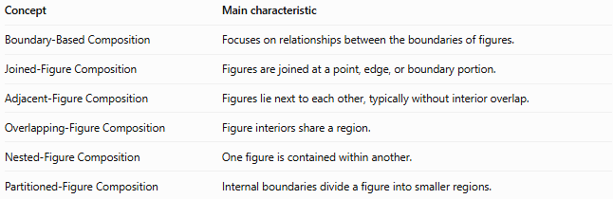
Concept | Main characteristic
Boundary-Based Composition | Focuses on relationships between the boundaries of figures.
Joined-Figure Composition | Figures are joined at a point, edge, or boundary portion.
Adjacent-Figure Composition | Figures lie next to each other, typically without interior overlap.
Overlapping-Figure Composition | Figure interiors share a region.
Nested-Figure Composition | One figure is contained within another.
Partitioned-Figure Composition | Internal boundaries divide a figure into smaller regions.
These categories can overlap. For example, two squares sharing a complete side are both a boundary-based composition and a joined-figure composition.

Classification Summary
# Source: AI Source: Provided by: [Data Path: Persons Table -> ID Column: 1, Name_En Column: Motasem Essam] -> From: [ChatGPT] on [7/25/2026]
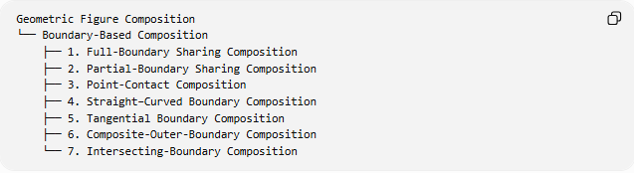
Geometric Figure Composition
└── Boundary-Based Composition
├── 1. Full-Boundary Sharing Composition
├── 2. Partial-Boundary Sharing Composition
├── 3. Point-Contact Composition
├── 4. Straight–Curved Boundary Composition
├── 5. Tangential Boundary Composition
├── 6. Composite-Outer-Boundary Composition
└── 7. Intersecting-Boundary Composition

Key Points
# Source: AI Source: Provided by: [Data Path: Persons Table -> ID Column: 1, Name_En Column: Motasem Essam] -> From: [ChatGPT] on [7/25/2026]
- Boundary-based composition focuses on how the boundaries of geometric figures relate.
- Boundaries may share a segment, meet at one point, touch tangentially, or intersect.
- Shared internal boundaries must be excluded when calculating the outer perimeter.
- Areas add directly when component interiors do not overlap.
- For overlapping figures, subtract the intersection area to avoid double-counting.
- Tangency is a special case of point contact, not a synonym for all boundary contact.

Conclusion
# Source: AI Source: Provided by: [Data Path: Persons Table -> ID Column: 1, Name_En Column: Motasem Essam] -> From: [ChatGPT] on [7/25/2026]
Boundary-Based Composition describes geometric configurations through the relationships between the boundaries of their component figures. It is useful for analyzing joined shapes, tangent figures, intersecting curves, composite perimeters, and areas of combined regions. The most important distinction is whether boundaries merely touch, share a segment, or cross, because each relationship affects area and perimeter calculations differently.

